Claire Lathrop on Olga Klimova (WizArt Visions)
http://www.olgaklimova.com/
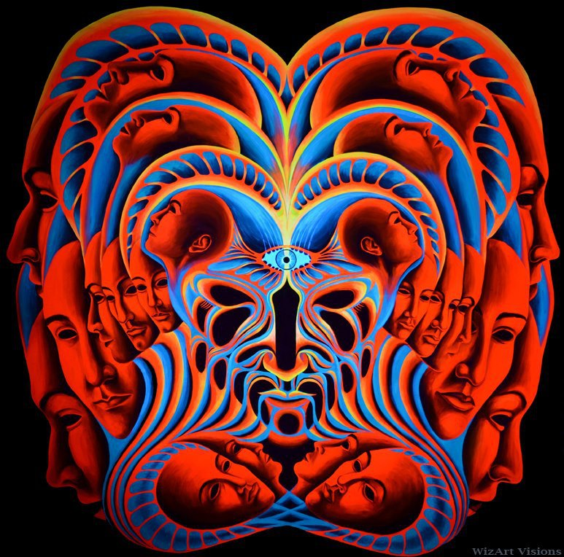
I met Olga Klimova In Colorado at a Sonic Bloom, a music and arts festival, in June of 2015, after speaking with her about her artwork and the yearning to portray visions and dreams, I was persuaded to attend the Kansas City Art Institute and begin painting. Our conversation revolved around the methods in which she used to see and depict her visions, as well as her experimentation of paint and materiality. We spoke of her practice and how it evolved from a more precise style to embracing the materiality of paint and going with the ‘flow’ of creation.
Original Backdrop, the Shaman1, 2010, flurescent acrylic on canvas, 6 x 5’
Original Backdrop, reflection, 2010, fluorescenct acrylic on canvas, 72 x 60”

Olga’s early style depicts the idea of the multiple and universal consciousness. Her visions are heavily influenced by her meditation and yoga practices where she manifests her visions of universal, all encompassing, consciousness among all living beings and the universe. Her work taps in the to direct link humans have to the need to feel connected to other beings, creating environments that curate this yearning and transcend what most feel. Her work, I believe shows the importance of a meditative practice that intertwines with the studio practice.
In this stage within her practice, she is attempting to depict precise visions. These works are intensely planned from start to finish before they are begun, leaving nothing up to chance.
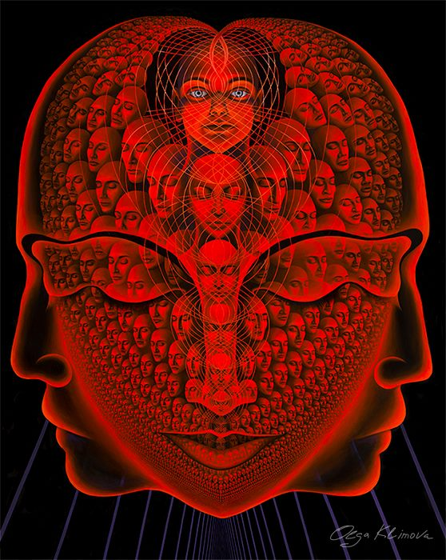
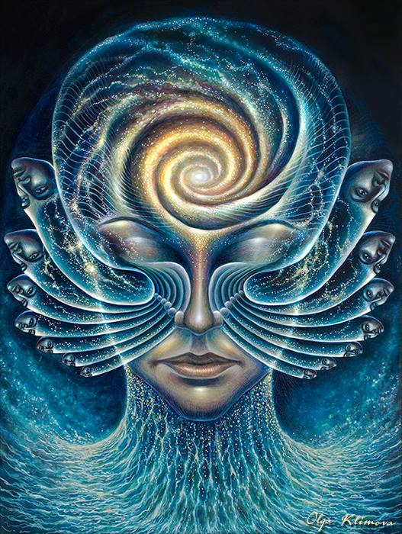
Manifestations, 2012, oil and egg tempera of board, 16x12”

The One, 2010, fluorescent acrylic on canvas, 72 x 60”

In contrast to her later work, Olga is embracing the idea of fluidity and materiality to portray and discuss the ideas in her earlier work. I can’t help but to feel that her early stage of work prepared her to be able to express herself in ways that incorporate flow and freedom of movement present in her later works. At some point in her practice, she was able to let go of knowing what the outcome would be and embracing the uncertainty and letting her creative intuition take control.

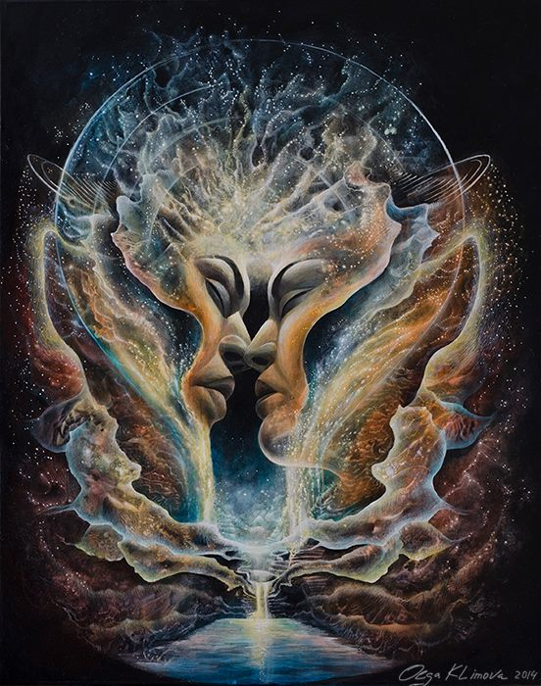
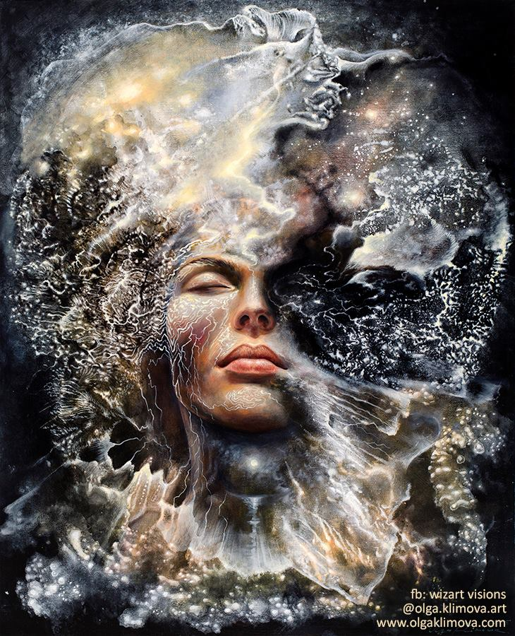
Reconnected, 2014, acrylic, oil, and casein on canvas, 24 x 30”
Dissolution of the Ego, 2015, acrylic, oil and casein on canvas, 30 x 24”

This newer, galactic and more sporadic style of painting is what I saw Olga creating live in June 2015, she started by allowing paint to spread and flow onto the canvas and meditating on the shapes that it created naturally. This intuition of painting better related to the subjects in which she is creating and for me, poses questions about the origin of this universal consciousness that she depicts. The process of painting Olga has adopted shows how her psyche and being have merged to become one with her means of expression. When I asked her what her driving forces were in the change, we had a discussion of her use of intense meditation and mindful use of psychotropic substances.

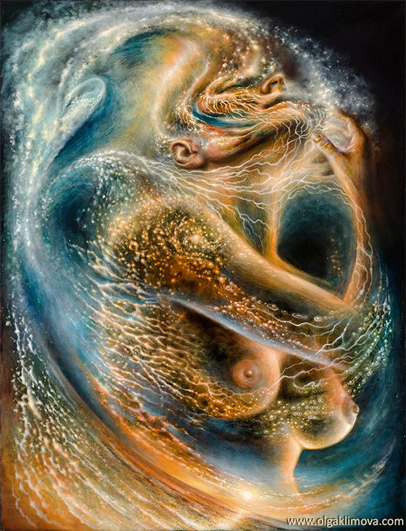
Sankhara, 2016, acrylic, oil and casein on canvas, 31.5 x 24”

Olga Klimova continues to have an active studio practice located in New York City, as well as traveling internationally to create live art installations. Seeing her be able to translate these same topics into very different styles inspired me to begin painting, as well as asking questions in regard to representation of the human form in my own work.

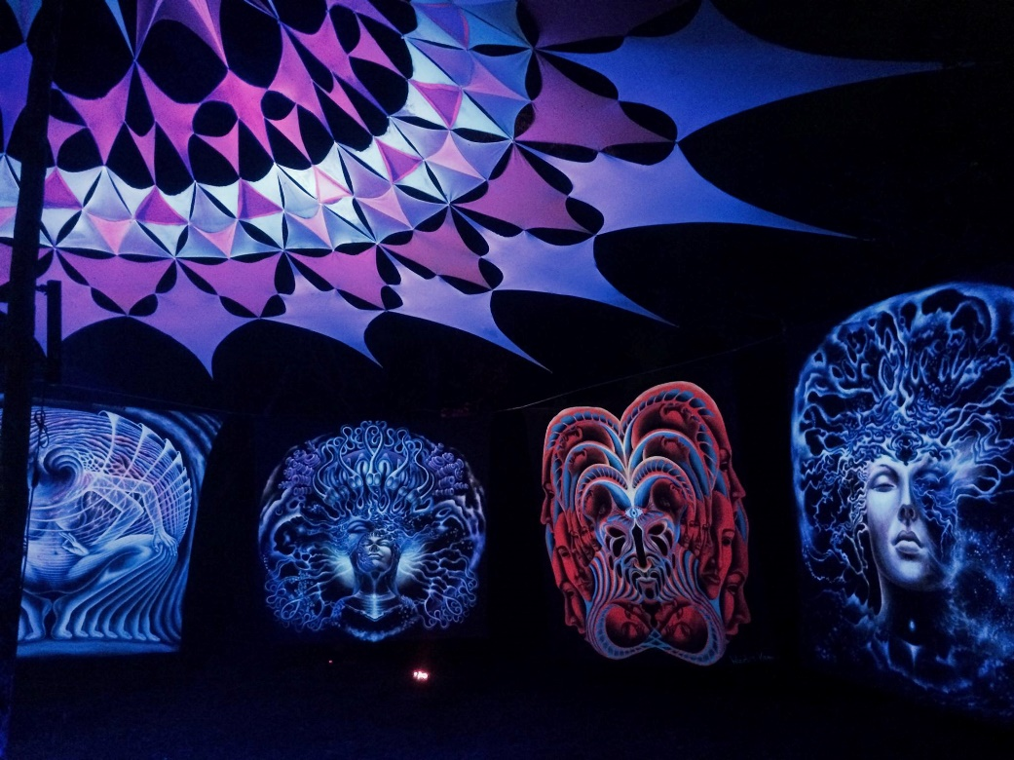
Installation of Olga’s work at Sonic Bloom in 2015.

The Unfolding, Claire Lathrop 2017
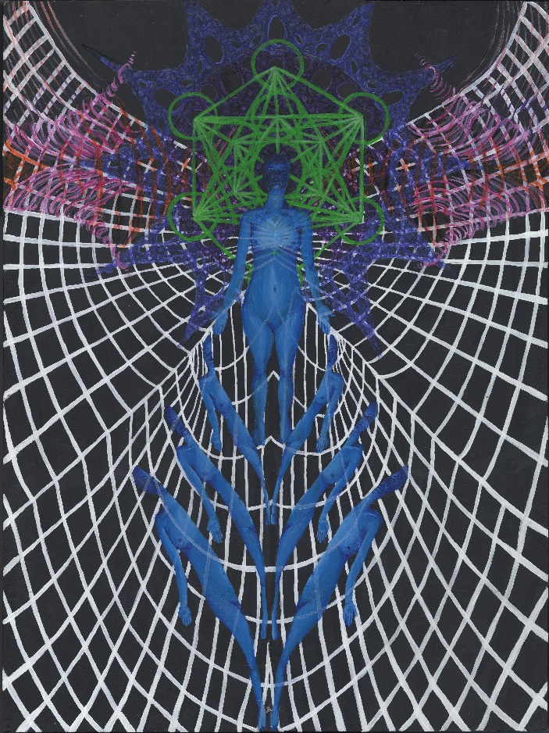
Transcendence, Claire Lathrop, 2017

