Depictions of Sex Work in the Northern Renaissance and Their Cultural Impact

Claire Lathrop
Northern Renaissance
Jan Kennedy
April 2019
Sex work. Prostitution. Whoring. Hoereriji. Promiscuity. Adultery. Courtesans. Whatever you call the use of a woman’s body, their agency, and profit from it, governments have maintained opinions about it since the beginning of civilization. These often-changing viewpoints were reflected in the artwork produced in their days. Prostitution, often, considered the oldest profession and the brothel the oldest institution, government, art, religion, literature, culture, and gossip have had their way with the perception of brothels and their workers. By examining the history, cultural beliefs, and the pieces of Jan Sanders van Hemessen’s Tavern or Brothel Scene (1545-1550) and Dirck van Baburen’s The Prodigal Son (1623), the cultural and societal implications of 16th and 17th century sex work and its ripples on the current use of prostitution in Holland can be examined.
Though some consider prostitution as the oldest profession in the world, contemporary research suggests that the title belongs rightfully to the midwife. The rise of exchanging sex for money seemed to arise with what we call civilization. The necessity for following a strict social code forced the mishaps of sexual deviances into the shadows and away from non-consensual settings. Although the word for prostitution was not invented until the 19th century, words like “whoring” were used in most languages (Hoereriji in Dutch). Historically, any instance where a woman is taking agency over her body or exercising her sexual desire fell into this category. One must understand when viewing the history of the regulation of “whoring” or prostitution, it is referring to the instances in which women are not following society’s proper view of moral or religious sexual practices.
In the middle ages, the forming of cities and larger villages allowed the business of prostitution to flourish. Lower class working girls were now afforded the option to move into cities and live their desired lifestyle under the guise of relative anonymity. With the cities becoming capitals and major hubs of trade throughout Europe, prostitution acted as an avenue to circulate capital among various class systems. Through the centuries, the sex trade began to diversify. Women would work out of theaters, bath houses, music halls, and pubs to continue selling their bodies regardless of the laws in place in any given location or time. Like other fast-growing cities like London and Paris, Amsterdam became known for its industries of sex for sale.
In 13th century Holland, a dam was built that created a river which flowed through multiple villages. Walls were built around the canal, constructing a network of connected villages around these walls, or Wallen. This area became known as de Wallen, which is now the contemporary Red Light District. The sex trade in this area has been booming since the 1400s where large quantities of sailors and traders passed through the canals. Mercenary soldiers were the most popular client of brothels and prostitutes from the 14th through the 17th century. Unlike many soldiers, their allegiance was bought, serving no real loyalty to any one source. Mirroring the prostitute’s eagerness to sell their body, these soldiers were considered an unruly and low class of society.
By becoming a major economic hub for Europe, it was critical that Amsterdam to begin circulating its newly introduced currency, and purchasing sex was one avenue that allowed this. Mid 17th century, Amsterdam had over 1,000 working prostitutes near the canals working under a few hundred brothel owners. Women selling their bodies typically worked in an institution called a whorehouse, or hoerhuizen, where there were one or two rooms containing a bawd, or hoerewaardin, that lived with one to three prostitutes or whores. In the late part of the 17th century, most prostitutes would hang out in musicos; these music halls were something that Amsterdam latter became famous for.
During 17th century, the Amsterdam government did not want any kind of prostitution within the city limits. The police force of only 30 made this preference impossible to enforce, but the 18th century brought more tolerance and regulation for sex work. In Hauge, anyone running a brothel was to be flogged, and many bawds and prostitutes were sentenced to beatings, jail time, or temporary banishment from the city. Re-offense rates saw that these punishments were wildly ineffective and proper rehabilitation was not in place. Out of all crimes prosecuted from 1650-1750, brothel-keeping consisted of 1/5th of them. It wasn’t until the 19th century that all kinds of “whoredom” were outlawed, whether money was exchanged or not. Although couples that were living together outside of marriage were seldom prosecuted, people who were committing adultery were taken without mercy or question, with the police paying off brothel owners to be informants.
Working girls were often from foreign or rural lands and were preyed on by bawds in order to indebt them. One bawd may have up to three women working for her at one instance, luring women that were poor, sick, pregnant, or unemployed into their care to become indebted. The only difference between the bawd and prostitute is their social standing and ability for capital. Bawds or procuresses had credit and the working girls lacked it, but the prostitution industry remained a female matter. Although bawds were typically married and the whores were not, the husband was not involved in the illegal work in fears of it tainting his honor. These owners would often transfer girls between them in order to have a constant stream of new faces.
The government recognized that this predatory system was making the orphaned population particularly venerable, making the recruitment of girls without families a severely punishable offense. By the government stepping in, it drove these kinds of operations underground. In social contrast to ‘whores’, courtesans were women who sold sex and glamour. They often were skilled conversationalists that were looked at more favorably than a traditional prostitute. Most whores could earn 6-8 guilders a week, which was near the wage of a skilled, schooled worker. The bawd took over half leaving a typical woman with only 3 guilders a week. Although often glorified in paintings, this profession was one shrouded in poverty, debt, desperation, social ostracization, and violence, but still allowed women more opportunities than they would have had before.
Through history, the church and its shifting beliefs played an influential role to the perceptions and laws regarding whoredom. The Catholic Church believed that sex work represented a necessary evil against greater offenses of rape and sodomy; Saint Thomas Aquinas compared whorehouses to sewers in a palace, they are needed for the palace to function or else it would be full of shit. And the Church never made a distinction of what qualifications made someone a whore, or officially decided whether or not they would take money from working girls if they weren’t repentant for their sins. In France, clergy made up a stunning 20% of brothel clientele. Bernard Mandeville, a Dutch doctor, said in 1724, “the encouraging of public whoring will not only prevent most of the mischievous effects of the vice, but even lessen the quantity of whoring in general and reduce it to the narrowest bounds which it can possibly be contained in.”
But the transformation of the Catholic to Protestant viewpoint represented a darker transition in the views towards sex and its worker. God no longer forgave sins– he punished them–and prostitutes and whores were already destined for hell. Women that used their money in order to dress up from their class were considered exercising not only lust, but pride as well. Martin Luther compared the Catholic Church to the whore because it accepted money for salvation, his comparison was a signifier of a shift in Europe to the disdain for brothels. With a combination of Luther’s condemnation and increasing outbreaks of syphilis, authorities started taking the closing of these institutions of immorality more seriously in the late 16th century. During this time, a slang vocabulary was built around the use of brothels by Catholic clergy. Brothels were called “convents” and prostitutes were called “nuns”. A man’s desire was marketed as only being satisfied within marriage to his wife, making it far more pleasurable than it would ever be with a whore.
The fascination with the Renaissance woman did not begin until the 1970’s with modern and second wave feminist movements. Depictions of the working woman, prostitute, and courtesans in scenes of music, food and monetary gain functioned as moralizing tales that could not help but to glamorize their positions in society and make the “John” or person buying sex look a fool, in contrast with literary works of 1700 that described the working women as “the scum of the people.” Often these negative comments referred to the woman’s act of dressing above their means in order to tempt men. Literary sources depicted things that the paintings ignored, describing the working women as too lazy to work real jobs and the emergence of the increasing venereal disease crisis.
Paintings that include depictions of whorehouses cluster in the 17th century. During the latter half of the century, over three thousand women were arrested for prostitution, most between the ages of 18-25, with only 5 were born within Amsterdam and the rest being migrants or immigrants. In contrast to the increase in depiction and arrests, there is no proof that there was an increase in the amount of sex work that was taken place as illegitimate births only accounted for 1% of total births and was much lower than centuries following.
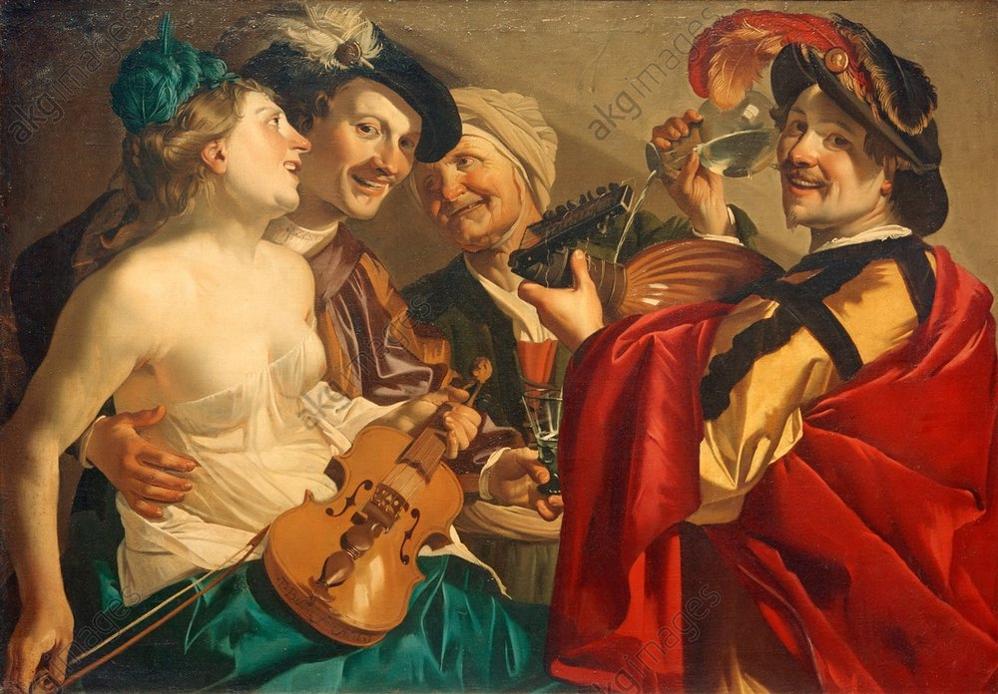
In most paintings for the time, the procuresses or bawds are central focuses. Usually being depicted as old women, most were around 35 years old with some being as young as the whores themselves. The parable of the Prodigal Son became a popular means of depicting the brothel scene, with the scantily dressed working woman and the foolish son being lured into cardinal sin. These depictions soon evolved into secular paintings that focus on the procuress rather than the biblical story itself, and they created the emergence of genre scenes in the 16th century. These paintings are believed to not be demonizing the act of sex, but rather the exchange of money. It was thought that the increased exchange of capital would cause a lust for goods that would potentially destabilize the community as a whole.
Dirk Van Baburen’s The Prodigal Son recounts a biblical tale of a son that was granted his inheritance to spend it on a number of things… including prostitutes. These scenes don’t recount the return and humility that the son will show in the future but focus on his sinning and vices within his failure. Baburen spent time in Italy studying the Italian Renaissance. During his time there, he focused primarily on religious scenes, but when he returned to Holland, Baburen moved to a more secular route promoting genre scenes in Dutch artwork. He is known for having a contemporary conversation with the Italian artists as a Dutch man, taking influences from witnessing Caravaggio’s style with the illuminated figures on a dark background. From studying in Italy, Baburen is credited with bringing a particular kind of mannerism to the northern Renaissance through genre scenes.
Dirk Van Baburen, The Prodigal Son, 1623
The Prodigal Son shows four figures engaging in a joyous scene of many vices. Two men can be seen engaging with music, wine, and a nearly nude woman. The man to the right of the painting is dressed in a large red cloak, black hat, and gold coat. He is gazing at the viewer with a large grin underneath his mustache. A lute, a traditional symbol for lust is clutched in his hands. To his left, the typical depiction of an elderly bawd can be seen. Wearing a head wrap and smiling with a gaped mouth, she is pouring the guests a beverage. She gazes up to her left at a handsome young man, whose glass she fills from above. His brown silk garment leads us to his beaming face. The whore can be seen in his arms, encapsulated by his embrace and looking at him with an expression of excitement. Her sheer garment is nearly exposing her breasts, although all of the shape of her nude body is viable. Disrobed, her garments are a lovely forest green to match the feather in her done-up hair. Within her arms, she holds a violin which is a symbol of merriment.
Unlike Baburen’s context of the story of the Prodigal son, Jan Sanders van Hemessen’s Tavern or Brothel Scene lacks any biblical context and just seeks to expose the vices in man and propose
the viewer with a moral choice. Hemessen studied in Italy in his early career like Baburen but came back to Antwerp for most of his career. He was famous for painting scenes that dealt with the follies of mankind, exposing the vices of everyday Flemish life in the 16th century. Earlier than Baburen, Hemessen was an artist that challenged conventions on what art was supposed to be.
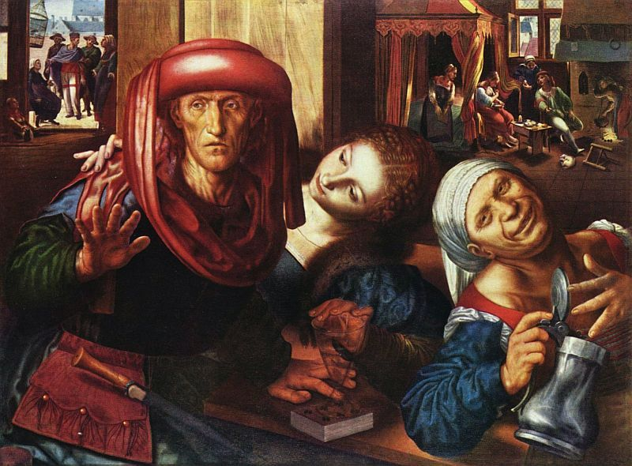
Jan Sanders van Hemessen crammed detail into the tavern scene, where it appears that a prostitute is making advances with the help of her bawd. Like previously discussed, the procuress is an older and unsightly woman and is the central focus that the viewer engages with on the right-hand side of the work. She’s dressed promiscuously with her shoulder coming out of her dress. With one hand on her chest and the other grasping an open metal pitcher, she gazes up at the viewer with a mischievous smile. Above the bawd’s wrapped head, there appears to be another group of five figures involved in indulgence within a darker background. To the left of the bawd, a young delicately painted woman is presumably trying to seduce her future customer. Her face is illuminated and smooth with tidily places curls on her head. The sex worker’s hand delicately touches the man’s glass on the table at the bottom of the painting while her other hand rests on his shoulder. The man that is being pursued looks off to the left of the work, avoiding the viewer’s gaze. His wrinkled skin is covered with richly colored fabrics in blue, red, and green. With one hand up, he seems apprehensive to their advances. His other hand rests gently on the bottom of the glass that the prostitute is caressing. To the left of the john’s head, there is an outdoor scene depicted outside of a window. Five figures interacting with a bird cage, and a doll sitting on the windowsill just to their left.
Jan Sanders van Hemessen, Tavern or Brothel Scene, 1545-1550
This scene leaves an interesting confrontation within the conversation: did this man welcome the advances? As a tavern scene, Hemessen depicts what could have been a regular encounter in a 16th century Dutch tavern. The tavern was considered was considered one of the many places that whore worked out of in order to men back to their bawd’s rooms. During this time, the government pushing prohibition of sex work would have forced larger brothels to close and forced women to work out of these kinds of environments in secrecy to continue their work. The Dutch government was less concerned with private arrangements of sexual desire, but rather were focused on driving these to less visible locations. These artworks represented a warning against the public display of lust, but simultaneously made it far more public.
The difficulty with the art revolving around sex work in 16th and 17th centuries in the Netherlands is that they don’t offer a comprehensive view of the industry and its many nuisances. These works and works similar show us the old and unsightly bawds and not young ones. We don’t see streetwalkers but rather whores in whorehouses or brothels. The artists omit venereal diseases, fighting, and police prosecution but show drunkenness, robbery, and cheating. We see taverns and brothels but never the music halls that made Amsterdam famous. We see musicians but no dancing. The artists paint desirable, young, and beautiful working girls but never ones that resemble a glimpse of aging. For these reasons, it is critical to examine the entirety of the history to understand the industry of sex work in the Dutch Republic.
Within a contemporary cultural lens, these works are often approached from a standpoint of feminine sexuality and freedom, except when it focuses on the male’s idea of pleasure. Within 17th century Dutch life, these acted as moral tales but were also scenes that were typical to see on a regular basis. By popularizing these idealized works of what sex work was like, artists painting genre scenes glorified and sanitized whoring all together. While trying to make an example of this moralizing situation, the artists effectively made it appear seductive, tantalizing and appealing to the viewer. It was not until the 20th century where artists and woman began looking at prostitution with an unromantic eye.
Throughout its history, Amsterdam has remained a capital of prostitution and the working girl. Whether underground and in secret or more overtly out in the open, the buying of sex remained a tourist attraction of de Wallen until the current day. Since 2000, prostitution has become legal in Amsterdam and in 2011, workers started being taxed just like everyone else. Brothel owners must receive a medical certificate, but workers are not required to get medical screenings in fear that it would perpetrate the idea that they are “dirty”.
The early introduction of genre scenes within the Flemish tradition allowed artists like van Hemessen and Baburen to exercise their interests in ideas and depictions of the illegal and unfavorable trades of their day. Although an inaccurate representation of the industry, the popularization of the work in classical and academically accepted art allowed the clean depictions of sex work penetrate the Dutch cultural awareness. It can be argued that the early introduction of these kinds of works normalized the trade and allowed the city of Amsterdam to flourish into one of the major European capitals that it is known as today. As a model of safe sex practices and an openness and regulation regarding prostitution, Holland continues to be known worldwide for the success of its policies and positive attitudes towards sex workers.
By examining the history, cultural beliefs, and the pieces of Jan Sanders van Hemessen’s Tavern or Brothel Scene (1545-1550) and Dirck van Baburen’s The Prodigal Son (1623), conclusions can be drawn about the moralizing messages and inaccuracies that artists displayed that set the stage for the current Dutch perspective on prostitution. From the introduction of genre scenes, brothels and the prostitution scenes began to perpetrate the Dutch societal psyche as early as the 16th century. Although sanitizing whoring, these works displayed women as smart, charismatic, and upsetting the power dynamic by taking control and making the modern older man a fool. Sex worker. Prostitute. Whore. Hoereriji. Promiscuous. Adulterer. Courtesan. Whatever you call the act of taking sexual agency over the female body, it afforded women more opportunities than before.

Works Cited
"A Brief History of Brothels." The Independent. September 17, 2011. Accessed April 04, 2019. https://www.independent.co.uk/news/uk/this-britain/a-brief-history-of-brothels-5336946.html.

Adams, Ann Jensen. "Money and the Regulation of Desire The Prostitute and the Marketplace in Seventeenth-Century Holland." Renaissance Culture and the Everyday, 1999. Accessed April 5, 2019. doi:10.9783/9780812291186.229.

Chagnon, Marianne. "Prostitution in the Netherlands: What Is Really Happening Here." Dutch Review. February 12, 2018. Accessed April 05, 2019. https://dutchreview.com/featured/prostitution-in-the-netherlands-what-is-really-happening-here/.

Coggins, Tom. "A Brief History of Amsterdam's Red Light District." Culture Trip. October 20, 2017. Accessed April 05, 2019. https://theculturetrip.com/europe/the-netherlands/articles/a-brief-history-of-amsterdams-red-light-district/.

Farago, Jason. "Courtesans and Street Walkers: Prostitutes in Art." BBC. September 10, 2015. Accessed April 04, 2019. http://www.bbc.com/culture/story/20150910-courtesans-and-street-walkers-prostitutes-in-art.

Franits, Wayne E. Dutch Seventeenth-century Genre Painting: Its Stylistic and Thematic Evolution. New Haven, Conn: Yale University Press, 2008.

Franits, Wayne. "Dirck Van Baburen and the “Self-Taught” Master, Angelo Caroselli." Journal of Historians of Netherlandish Art5, no. 2 (2013). doi:10.5092/jhna.2013.5.2.5.

"Jan Sanders Van Hemessen." Oxford Reference. June 16, 2017. Accessed April 05, 2019. http://www.oxfordreference.com/view/10.1093/oi/authority.20110803095930295.

McCoy, E. "Has the Oldest Profession in the World Really Changed? A Short History of Dutch Prostitution and Government Regulation of Prostitution in the Netherlands." Umassd. 2013. Accessed April 5, 2019. http://www1.umassd.edu/euro/2013papers/mccoy.pdf.

Pol, Lotte Van De. "The Whore, the Bawd, and the Artist: The Reality and Imagery of Seventeenth-Century Dutch Prostitution." Journal of Historians of Netherlandish Art2, no. 1-2 (2010). doi:10.5092/jhna.2010.2.1.3.

Ringel, Lucien. "History of Prostitution." YouTube. February 20, 2018. Accessed April 05, 2019. https://www.youtube.com/watch?v=NMqNCPihZoY.

Victoria, Albert Museum, and Digital Media. "Women in the Renaissance." Women in the Renaissance. July 15, 2014. Accessed April 05, 2019. http://www.vam.ac.uk/content/articles/w/women-in-the-renaissance/.

Pol, Lotte Van De. "The Whore, the Bawd, and the Artist: The Reality and Imagery of Seventeenth-Century Dutch Prostitution."
"A Brief History of Brothels." The Independent
Pol, Lotte Van De. "The Whore, the Bawd, and the Artist: The Reality and Imagery of Seventeenth-Century Dutch Prostitution."
Ibid.
Ringel, Lucien. "History of Prostitution."
Ibid.
Pol, Lotte Van De. "The Whore, the Bawd, and the Artist: The Reality and Imagery of Seventeenth-Century Dutch Prostitution."
Coggins, Tom. "A Brief History of Amsterdam's Red Light District."
Adams, Ann Jensen. "Money and the Regulation of Desire The Prostitute and the Marketplace in Seventeenth-Century Holland." Pg 238
Adams, Ann Jensen. "Money and the Regulation of Desire The Prostitute and the Marketplace in Seventeenth-Century Holland." Pg 237
Pol, Lotte Van De. "The Whore, the Bawd, and the Artist: The Reality and Imagery of Seventeenth-Century Dutch Prostitution."
Ibid.
Ibid.
Adams, Ann Jensen. "Money and the Regulation of Desire The Prostitute and the Marketplace in Seventeenth-Century Holland." Pg 234
Pol, Lotte Van De. "The Whore, the Bawd, and the Artist: The Reality and Imagery of Seventeenth-Century Dutch Prostitution."
Ibid.
Ibid.
McCoy, E. "Has the Oldest Profession in the World Really Changed? A Short History of Dutch Prostitution and Government Regulation of Prostitution in the Netherlands." Pg 5
Pol, Lotte Van De. "The Whore, the Bawd, and the Artist: The Reality and Imagery of Seventeenth-Century Dutch Prostitution."
"A Brief History of Brothels." The Independent
McCoy, E. "Has the Oldest Profession in the World Really Changed? A Short History of Dutch Prostitution and Government Regulation of Prostitution in the Netherlands." Pg 5
Farago, Jason. "Courtesans and Street Walkers: Prostitutes in Art."
McCoy, E. "Has the Oldest Profession in the World Really Changed? A Short History of Dutch Prostitution and Government Regulation of Prostitution in the Netherlands." Pg 5
Franits, Wayne E. Dutch Seventeenth-century Genre Painting: Its Stylistic and Thematic Evolution. Pg 69
"A Brief History of Brothels." The Independent
Ringel, Lucien. "History of Prostitution."
Ibid.
Ibid.
"A Brief History of Brothels." The Independent
Pol, Lotte Van De. "The Whore, the Bawd, and the Artist: The Reality and Imagery of Seventeenth-Century Dutch Prostitution."
Ringel, Lucien. "History of Prostitution."
McCoy, E. "Has the Oldest Profession in the World Really Changed? A Short History of Dutch Prostitution and Government Regulation of Prostitution in the Netherlands." Pg 3
Ringel, Lucien. "History of Prostitution."
Adams, Ann Jensen. "Money and the Regulation of Desire The Prostitute and the Marketplace in Seventeenth-Century Holland." Pg 234
Victoria, Albert Museum, and Digital Media. "Women in the Renaissance."
"A Brief History of Brothels." The Independent
Pol, Lotte Van De. "The Whore, the Bawd, and the Artist: The Reality and Imagery of Seventeenth-Century Dutch Prostitution."
"A Brief History of Brothels." The Independent
Adams, Ann Jensen. "Money and the Regulation of Desire The Prostitute and the Marketplace in Seventeenth-Century Holland." Pg 232
Pol, Lotte Van De. "The Whore, the Bawd, and the Artist: The Reality and Imagery of Seventeenth-Century Dutch Prostitution."
Franits, Wayne E. Dutch Seventeenth-century Genre Painting: Its Stylistic and Thematic Evolution.
Adams, Ann Jensen. "Money and the Regulation of Desire The Prostitute and the Marketplace in Seventeenth-Century Holland." Pg 237
Franits, Wayne E. Dutch Seventeenth-century Genre Painting: Its Stylistic and Thematic Evolution. Pg 68
Franits, Wayne. "Dirck Van Baburen and the “Self-Taught” Master, Angelo Caroselli."
Franits, Wayne E. Dutch Seventeenth-century Genre Painting: Its Stylistic and Thematic Evolution. Pg 67
"Jan Sanders Van Hemessen." Oxford Reference.
Pol, Lotte Van De. "The Whore, the Bawd, and the Artist: The Reality and Imagery of Seventeenth-Century Dutch Prostitution."
Adams, Ann Jensen. "Money and the Regulation of Desire The Prostitute and the Marketplace in Seventeenth-Century Holland." Pg 237
Pol, Lotte Van De. "The Whore, the Bawd, and the Artist: The Reality and Imagery of Seventeenth-Century Dutch Prostitution."
Franits, Wayne E. Dutch Seventeenth-century Genre Painting: Its Stylistic and Thematic Evolution. Pg 69
Farago, Jason. "Courtesans and Street Walkers: Prostitutes in Art."
Chagnon, Marianne. "Prostitution in the Netherlands: What Is Really Happening Here."
Ibid.
Pol, Lotte Van De. "The Whore, the Bawd, and the Artist: The Reality and Imagery of Seventeenth-Century Dutch Prostitution."

